Study of Performance of Routing In TORA Protocol Using ETX as Metric

Vikash Kumar

*Department of Computer Science and Engineering*

*Registration ID: INS1254*

*Contact Number: +91-8553901280*

*Hubli,India*

[Vikashkumar1143k3@gmail.com](mailto:Vikashkumar1143k3@gmail.com)

***Abstract:***

**This paper presents the implementation of ETX (Expected Transmission Count) plugin in TORA protocol. ETX metric chooses the most optimum and high throughput path in terms of link quality for the destination. ETX metric takes care of link loss ratio and uses link quality as a metric for finding the high throughput path. It overcomes the conventional metric of hop count as many a time a route with less hop count may give less throughput than one in a route with high hop count. Such cases happen when the quality of link between two nodes is quite low means there is no guarantee that receiver will receive the packet. ETX metric takes care of such links and involve transmissions and retransmissions of packets to calculate transmissions and retransmissions ratios and then select a path.**

**This paper describes the designof ETX metric done in in TORA protocol. It also describes the working of TORA protocol and modifications done in it to implementation ETX as metric in routing the packets and how performance of the network improve after plugin the ETX in TORA protocol. All the measurements are taken after having simulation on NS-2.34 and the output suggest that the performance of the network has improved in terms of throughput, delay, overhead and packet delivery ratio. This implementation will be of immense help for the researchers who want to implement the ETX metric for any other reactive protocol.**

**Index Term: mesh-topology, routing, MAC, NS-2.34, X-graphs**

I. INTRODUCTION

Wireless network is the most preferred network in modern era leaving behind the inefficiency of wired network where the portability of network was a major concern. Wireless technology has been touching the sky due to its flexibility, portability, bandwidth efficiency and many other things. In wireless network too there are different types of network like wireless mesh network, wireless hybrid mesh network, wireless local area network, wireless personal area network and various others. But in all of the above mentioned networks wireless mesh network has attracted a lot of attention to the researchers.

Wireless networks consist of mobile nodes which means nodes can change their location based on the configuration of the network. Here the nodes on its own can modify themselves to the adjusting environment to work properly. No manual working is required if any link fails somewhere rather it will change on its own through the network. In wireless mesh network data packets are desultory in nature means they keep on jumping from one node to another node until it finds the destination. Routing algorithms are implemented in each node or device to make this jumping happen which usually consider the path dynamically.

In wireless network the most important aspect of routing the packet to its destination is the route metric. This is because until the most efficient route is not selected the performance of the network is not going to increase. The packet which contains the information should reach to the destination as soon as possible means with minimum end to end delay. Also the information which is in the packet at source must reach the destination without being tampered or without any loss. So keeping these things in mind the routing metric seems to be the most important part of wireless networks. Traditionally the routing metric which is still in use in various protocol is the minimum hop count metric. In this metric when the source sends a packet to a destination then the packet which contains the information and the destination address try to find out the route in which there are minimum number of nodes to be countered. By this way it results in minimum time in which it covers the whole distance. The problem with such approach is that even if packet chooses the shortest path, sometimes link quality through that path may not be efficient, which means there could be any other path along which the link quality may be good enough to route the packet and that path may be the longer path. But in such case longer path is more efficient than the shorter one as intended information is received by the receiver safe and sound.

ETX (Expected Transmission Count) overcomes such problem in routing protocol. ETX basically uses the delivery ratios, there are two types of delivery ratio one is forward delivery ratio and the other one is reverse delivery ratio. In minimum hop count metric there are two assumptions about the link and they are either link is working or the link is not working. It does not consider the third part which is what if link quality is not good enough but not bad enough too. So ETX intends to find the path the path in which minimum number of transmissions and retransmissions are needed to successfully deliver a packet. So ETX is able to find the path with maximum throughput in spite of the loss in link quality.

In order to show the working of ETX efficiently this paper shows the measurement of the performance of the network in terms of throughput, end to end delay, packet delivery ratios and overhead for TORA protocol with number of nodes being equal to 10. The measurement of each of the above mentioned parameter shows that the performance of the network improves in terms of its throughput, goodput, end to end delay, overhead and packet delivery ratio.

Rest of the paper is organized as follows: Section 2 describesthe related work about ETX. Till today therehas not been any work on the TORA protocol with ETX. Section 3 at first explains why minimum

hop-count often finds routes with significantly less throughput than the best available and then it presents the design, implementation, and evaluation of the ETX metric. Finally, it describes a set of detailed design changes to the TORA protocols (to which ETX is an extension), that enable them to more accurately choose routes with the best metric. Section 4 shows the results displayed after evaluating ETX metric by making use of X-graphs and execution of AWK scripts, and Section 5 concludes the paper.

II RELATED WORK

The nature of routing protocol over lossy link has been addressed in several researcher’s paper. The different authors have different view on the performance of routing protocol plugged with ETX metric.

Author [3] after research came to conclusion that the ETX finds a route with significantly higher throughput than the customized minimum hop count metric particularly for paths having more than two nodes. He also suggested that several network performances based on ETX can be improved in coming future. Author[2] came up with the fact that overhead of ETX delivery ratio probes depends on the spatial density of the network and is relatively small compared to the amount of data traffic that can be sent over each link. Author [5] put emphasis on how ETX calculates less lossy link as compared to the minimum hop count which eventually lead to higher throughput in the network. Besides these ETX metric has also been recently implemented in OLSR which is a proactive protocol.Author [9] examined the performances on 23 nodes static ad hoc network in an office environment. There the result showed that with stationary nodes the ETX metric significantly outperforms hop count.

After various research the common thing among all seems to be the nature of output in terms of network performances which increases significantly in case of static topology than topology with mobile nodes. Also the variation in output is not uniform for any number of nodes.

To implement ETX in any of the protocol researchers[6] tried to understand the meaning and complete definition of ETX. And then they came up with an ETX formula that can easily be applied and implemented for any of the protocol. Researchers defined ETX as Expected Transmission Count (ETX) is a metric that finds high throughput path on multi-hop wireless networks incorporating the effects of link loss ratios and interference among the successive links of a path.

Research has further been carried out [10] to show that ETX metric performs better than hop count metric. Minimum hop-count metric regardless of large differences in throughput, chooses different paths of some minimum length. This metric also account to issues like interference between successive hops among multi-hop paths. ETX metric provides better improvement for paths with two or more hops, suggesting that transmission count offers increased benefit as network grows larger and path become longer. Research has been done on various steps[7] to implement new protocol in NS-2. A detailed description on various procedures and files to be included in NS2 was proposed by the researchers.

III PROPOSED WORK

This section describes the working of TORA protocol when plugged in with the ETX metric. Here the description of factors will be dealt which is important part of ETX metric implementation in wireless mesh network. TORA protocol is known to be one of the most efficient routing protocol when matters come to the number of nodes. In terms of performance TORA is inefficient than the other reactive protocols link AODV and DSR when the number of nodes are less but as the number of nodes increases performance gets better and better. So, one of the contribution of this paper is to improve the performance of the network for less number of nodes. In fact this is the central idea of this paper.

ETX metric uses both MAC layer and network layer features like number of transmissions from MAC and based on ETX routing will happen at the network layer. The ETX in TORA proves to be an appealing cost metric because minimizing the total number of transmissions and retransmissions maximizes the throughput of an individual link and then overall network. We shall discuss the modifications to be done for some of the files in NS-2 to include ETX metric in TORA. We also present the changes to be made to TORA protocol to calculate the value of ETX which is used while routing the packets.

*A.Working of TORA:*

TORA can be called as a highly adaptive routing algorithm which works on a special type of algorithm known as link reversal algorithm and the biggest advantage of this protocol is that it is able to provide more than one path for the destination provided there are alternate paths. Each node has to send the query to a particular destination explicitly on its own and dynamically. Here there are three parts which are the basic of TORA. Those three parts are 1. Route Creation 2. Route Maintenance 3. Route Erasure.

TORA aims at creating the directed Acyclic Graph (DAG)whose root is at the destination with the height set as NULL. All the other nodes have a relative unique height and a packet can flow from only node with higher height value to the node of a low height. Such links are called DownStream Link while the link in which link is there in between lower to higher node then such links are called UpLink and a packet cannot flow when the link is UpLink. Heights are assigned to each nodes with reference to the root node which is destined at the destination. If a link is working fine then there is no problem in forwarding the packets but if a link doesn’t work fine or it gets failed then there comes the role of Link Reversal algorithm.

Link reversal algorithms are of two types one is full link reversal algorithm and another is partial link reversal algorithm. Full link reversal algorithm requires O(n2) work and time where n is the number of nodes that have lost the route to the destination and this bound is tight in the worst case. A graph in which a single destination is there is called as destination oriented otherwise destination disoriented graph. The main objective of this algorithm is to create and maintain the route to the destination.As the nodes are mobile sometimes it may happen that two nodes may get out of range of transmission. So, in such cases routing algorithm reacts by performing full link reversal algorithm so that the integrity of the graph remains and the graph doesn’t break apart. In full link reversal when a node becomes a sink it reverses the direction of all of its incident link thus giving a new height to each and every node, while in partial link reversal algorithm only that link gets reversed which has not been recently reversed by the adjacent nodes.

Each node in TORA has an associates height and is represented by a quintuple h (I) ={first, second, third, fourth, fifth}. The first three are called the reference level and the last two are called offset. First is the time at which link fail occurred. Second is the id of the originating node, third is a one bit value is for reference level and may be 0 or 1, fourth one is an integer value used to order nodes with respect to reference level and the last one is ID of the node itself. Initially height of each node is set to be NULL while the height of destination is set to be 0 since all the references are taken from the destination only.Now when the packet starts flowing in the network and the graph algorithm comes into play then each node is assigned a unique height and depending on the height the link is UpLink or DownLink. And in certain circumstances there can be more than one DownLink from a node so multiple paths are possible in this protocol.

Route creation is the initial phase of TORA protocol and requires two types of packet namely QUERY type packets and UPDATE type packets. Here in QUERY packet a field with the destination ID is there which searches for the destination and on successful search it routes the packet to that particular destination. In between if the node moves outside the transmission range of the other node then UPDATE packet is used to apply the link reversal algorithm and modify the link in network. The responsibility of the UPDATE packet is route maintenance. When a link fails there is possibility of partitioning the nodes and if the partition occurs then route erasure mechanism comes into picture whose sole objective is to erase and dump the route which has been left out so that it doesn’t disturb the further routing mechanism.

*B.Changes to be made to be made to TORA to calculate ETX*

*1) Tora_packet.h*

In packet header file there are three types of packet namely QUERY type, UPDATE type and CLEAR type and these are not enough to implement ETX because there is necessity to check the link quality. So one PROBE type packet is considered. It has got total of six different fields namely type (to indicate packet type), source (to indicate the source from which the packet was sent), neighbour count (to count the number of neighbour), address neighbour (to store the address of each neighbour), probe count (to count the number of probe received from each and every neighbour), and timestamp (to store the time at which probe packet was sent).

*2) Tora.cc*

This is the most important part of TORA protocol. It deals with the various functionality of the protocol like timer function for time out mechanism, type of packets received, and the actions taken after receiving those packets. Here in this file first of all three timers are added namely ProbeTimer, WindowTimer and ManagementTimer. The function of ProbeTimer is to send the PROBE type packet which has been defined in the packet header file to the destination at the regular interval. This sending of packet is done by the scheduler function. At the same time it will call sendETX() function in which the packet will check for all of its neighbour one by one and store the address of each neighbour and total count of nodes present as the neighbour.And after that all the fields of the PROBE type packet gets updated with the modified values as the new value. Once the updating is done the scheduler function is called again which in turn call the ProbeTimer function and then the process repeats. Second type of timer is WindowTimer which calls HandleProbeWindowTimer() where the packet goes to each and every neighbour and from there it calls updateReverseDelivery() function. In updateReverseDeliveryRatio(), reverse delivery ratio for each and every particular neighbour is calculated. The formula for the reverse delivery ratios goes like this:



The third type of the timer is ManagementTimer and this timer function calls manageETXProbe() function at the regular interval whose main function is to remove the unused packets present in the network so that they can’t disturb the flow of the others packets roaming in the network. Now when the PROBE type packet is received at any node then recvPROBE() function is called. In this function total number of neighbours is count present in the vicinity of the PROBE packet. Once counting is done updateForwardDeliveryRatio() function is called where the forward ratio is calculated by sending the PROBE packet to the actual number of packets received in the network.The calculation of the forward delivery ratio is done as follow:



Once forwardDeliveryRatio and reverseDeliveryRatio is calculated for each and every node then there is a need to calculate ETX. ETX is calculated by this formula:



The path is selected in which there is minimum sum of total ETX and thus giving the improved throughput, delay, overhead and packet delivery ratio. Whenever route update happen then at that point of time forward and reverse delivery ratio is calculated and then ETX is calculated and it is checked against the PROBE_WINDOW size. If it is less than only the packets route via that route through which lowest sum of ETX is there.

IV Result Analysis

In this section, we present simulation results comparing the performance of TORA-ETX with TORA under different performance parameters.

1. *Simulation setup*
2. *Scenario*: NS-2.34 simulator is used for the simulation study.The model parameters that have been used in the following experiments are summarized in table 1.

TABLE 1: SIMULATION PARAMETERS

|  |  |  |
| --- | --- | --- |
| **SI NO.** | **Parameters** | **Values** |
| 1 | Routing Protocol | TORA, TORA-ETX |
| 2 | Channel | Wireless channel |
| 3 | Simulation time | 45 seconds |
| 4 | Number of Nodes | 10 nodes |
| 5 | Bandwidth | 1Mbps |
| 6 | Traffic Type | FTP |
| 7 | Packet Size | 512 bytes |
| 8 | Simulator | NS-2.34 |

1. *Evaluation:*The following performance parameters are used to evaluate the protocol:

*Average End to End delay:* This metric represents average end-to-end delay and indicates how long it took for a packet to travel from the source to the application layer of the destination. It includes all possible delay caused by buffering during route discovery latency, transmission delays at the MAC, queuing at interface queue, and programming and transfer time. It is calculated using the formula:



*Packet delivery ratios:*This parameter is defined as the ratio of total number of packets successfully received by the destination nodes to the number of packets sent by the source nodes throughout the simulation which is given as:



*Normalized Routing Load:* This parameter is defined as the ratio of total number of routing packets received to the total number of data packets received which is given as follow:



*Goodput:*This parameter is defined as the ratio of total number of routing packets excluding retransmitted packets to the total amount of time taken which is given by the following formula:



*Throughput:*This parameter is defined as the ratio of total number of routing packet including retransmitted packets to the total amount of time taken which is given by the following formula:



1. *Results:*

In this section we present the performance results in the form of numerically calculated values of Average end to end delays, packet delivery ratios, normalized routing overhead for both TORA and TORA-ETX. We also compare the performance of TORA-ETX versus TORA in the form of X-graph obtained after simulation which shall prove that the performance of TORA-ETX is better than the TORA alone.

1. *Results of Numeric calculation:* The numerical results obtained after the execution of TORA and TORA-ETX are given in Table II.

TABLE II: NUMERICAL RESULTS

|  |  |  |  |
| --- | --- | --- | --- |
| **SI.NO.** | **Performance Parameters** | **TORA** | **TORA-ETX** |
| 1 | Throughput | 711.74kbps | 714.20kbps |
| 2 | Packet Delivery Ratio | 20.0605 | 20.5233 |
| 3 | Normalized Routing Overhead | 0.445 | 0.412 |
| 4 | Goodput | 650.4kbps | 654.01kbps |

1. *Results in the form of X-graph:*

*Average End to End delay:* In TORA, there exist many paths between a source and a destination node and hence during a link break the packet would not reach the destination via that very path on which the packet was intended to go but there may be certain other path. When using the alternative path again the configuration needs to be changed in the routing algorithm but then also it cannot be ensured that the path which packet has selected is the efficient one or inefficient. This packet increases the traffic which leads to the congestion in the network. In TORA-ETX when a link breaks the ETX value changes to INFINITY (some large value) which indicates the absence of the link. In such a case another path with the lowest ETX value is considered by the node to forward the packet. Thus an alternate path exists from source to the destination during link failure.

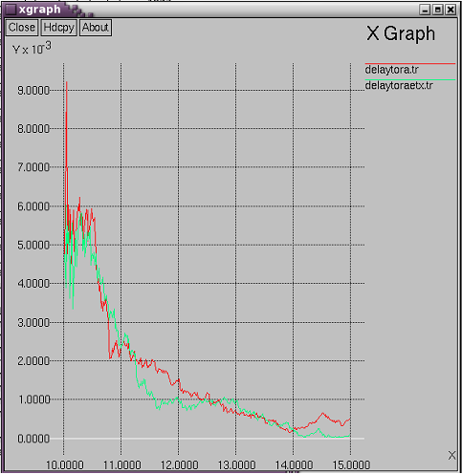

Fig. 1 Comparison of End to End delay

Whenever a link is busy in case of TORA the sending node waits until the link gets free whereas in TORA-ETX another path is chosen to forward the packet instead of waiting for the link to get free. This extra time spent by the sender waiting for the link to get free. This extra time spent by the sender waiting for a free link increases the total delay. Thus, TORA has an average delay of 654.553ms to TORA-ETXs average delay of 557.266ms which reveals that note that TORA-ETX has better average delay than TORA. There is 17.46% improvement in average delay from TORA to TORA-ETX. Green curve is for TORA-ETX while red one is for TORA.

*Packet delivery ratio:* The X-graph of packet delivery ratio versus the simulation time indicates that for most of the time the packet delivery ratio of TORA-ETX is higher than TORA and thus the average value of the packet delivery ratio for the entire simulation time for TORA-ETX is higher than TORA. Thus, TORA has a packet delivery ratio of 20.0605 to TORA-ETXs packet delivery ratio of 20.5233.Thus there is 0.5628 improvement in packet delivery ratio from TORA to TORA-ETX. Green graph shows packet delivery in TORA-ETX while red one shows for TORA.

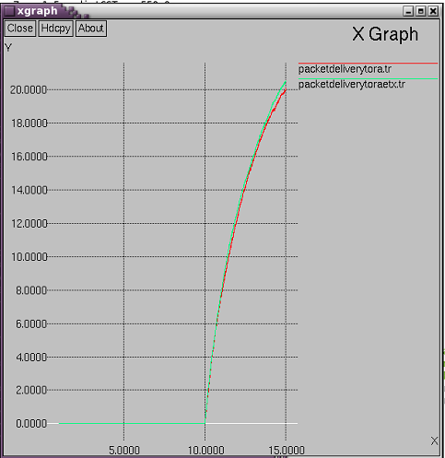

Fig. 2 Comparison of Packet delivery

*Normalized routing overhead:*The normalized routing load is number of routing packets sent per number of data packet received. From Fig. 3 it can be observed that TORA-ETX has less routing overhead compared to TORA. In TORA-ETX in spite of the fact that an extra PROBE packet is required to deliver the packet the overhead does not increase rather it reduced and this is due to the fact that retransmitted packets sent and received has been minimized in the network due to ETX. TORA-ETX has a normalized routing value as 0.412 while in TORA it is 0.445 leading to 7.41% increase in the value. Here also red one shows the graph for TORA while green one is for TORA-ETX.

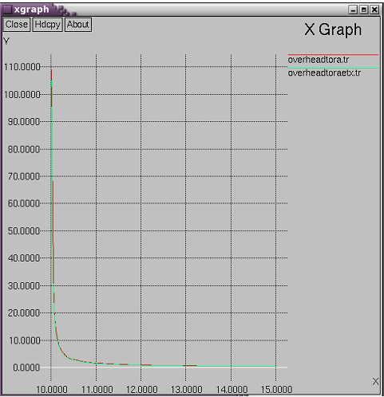

Fig. 3 Comparison of Overhead

*Goodput:*Goodput of a network is defined as the total amount of useful packets sent over a network in any particular interval of time. Goodput does not consider the packet which gets lost while travelling from source to the destination rather it accounts for only those packets which reach at destination successfully. Calculation of goodput in TORA-ETX shows an improved result as compared to TORA. In TORA-ETX goodput value comes as 654.5 kbps while in TORA it comes down to 650.0 kbps. Here there is not a significant increase in the value but relatively it is better than the normal TORA. So, TORA-ETX shows 0.61% increase in goodput than TORA. Red graph is for TORA while green graph is for TORA-ETX.

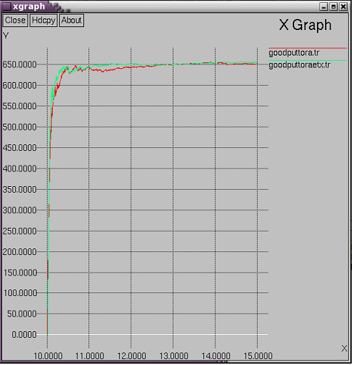

Fig. 4 Comparison of Goodput

*Throughput*: Throughput of a network is the defined as the total amount of packets sent over a network in any particular interval of time. Unlike goodput, it also consider the packet which gets transmitted while travelling from source to the destination due to network conflicts or error in the network. Calculation of throughput in TOR-ETX shows an improved results as compared to the normal TORA. In TORA-ETX throughput value comes as 714.5 kbps while in TORA it comes down to 711.0 kbps. Here there is not a significant increase in value but relatively it is better than the normal TORA. So, TORA-ETX shows 0.49% increase in throughput than TORA. We can easily see that the goodput value has increased more than the throughput which means effective and useful number of packets reaching at destination is more. Red is for TORA while green is for TORA-ETX.

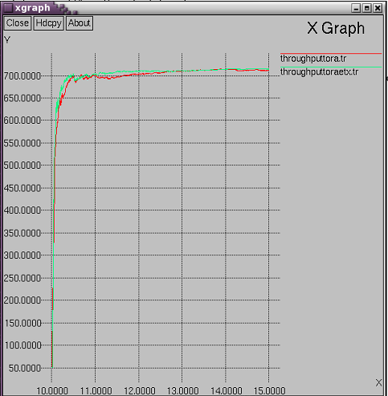

Fig 5. Comparison of Throughput

V Conclusion and future scope

This paper compare the performance of TORA and TORA with ETX plugged in. The simulation is carried on NS-2.34 for ten nodes. The ETX metric plugged in with TORA gives better performance than simple TORA. Here four parameters have been taken into account to calculate performance. The parameters are throughput, packet delivery ratio, overhead and end to end delay. The outcomes are taken in the form of graph and the results are quite staggering. All the four parameters have improved.

In coming future the ETX can be modified to select the path best suited for the network like if link quality is good then go for minimum hop count and when link quality is not perfect then go for ETX metric implementation. Nearly every link has some link loss. Also here the implementation is done for TORA protocol which is one of the reactive protocol. So now the same metric can be implemented for other reactive protocol like DSR and other proactive protocols.

ACKNOWLEDGMENT

Any work accomplished cannot be perfect without the help and guidance of certain experienced and intellectual persons. So, here we are acknowledging our sincere respect to them without whom this project could not have been done.

First and foremost we would like to express our sincere thanks and gratitude to the principal, B.V. Bhoomaraddi College of Engineering and Technology, Dr. Ashok Shettar, and head of the department, Computer Science of Engineering, Prof. K.R.Biradar for providing all the necessary requirements to get the work done smoothly and on time.

We would also like to thank Prof. Jayalaxmi G.N for guiding us in the right direction and for proving the right feedback time and again.

REFERENCES

*[1]Lijun Chen, Steven H.Low and John C. Doyle. Cross-layer design in multihop wireless networks, 2010*

*[2] Douglas S.J. De Couto, High-throughput routing for multi-hop wireless networks, 2003*

*[3] Douglas S.J. De Couto, Daniel Aguayo John Bicket, and Robert Morris.A high-throughput path metric for multi-hop wireless routing, 2003.*

*[4] A.K. Dwivedi, Sunita Kushwaha and O.P. Vyas “Performance of routing protocol for Mobile Adhoc and Wireless Sensor Network”, A comparative study, volume 2.International Journal of recent trends in Engineering, 2010.*

*[5] Nadeem Javaid, Akmal Javaid, Imran Ali Khan and Karim Djouani. “Performance study of ETX based wireless routing metric”, Computer, Control and Communication, 2009.IC4 2009. 2nd International Conference on 17-18 February, 2009.*

*[6] Vincent D. Park, Draft-ietf-mant-tora-spec-00, 26 November 1997.*

*[7] Francisco J. Ros and Pedro M. Ruiz. Implementing a new MANET unicast routing protocol in NS-2, 2004.*

*[8] Douglas C. Schmidt. Software design principles and guidelines, 2003.*

*[9] Sumathy S. and Dr. R. Saravanan. “ETX metric for extremely opportunistic routing to improve the performance of hybrid Wireless Network”, International Journal of Ad hoc, Sensor & Ubiquitous computing (IJASUC) vol. 2, No. 4, December 2011.*

*[10] Richard Draves, Jitendra Padhye, Brian Zill. Comparison of routing metrics for static multi-hop wireless networks, 30th August, 2004.*